Cervical Assessment Project Results

Sociodemographic Characteristics

The age distribution was fairly balanced, with the largest age group being 35–45 years (28.1%), followed by 25–34 years (27.0%). Most participants resided in Bolgatanga Municipal (70.7%) and were either self-employed (45.4%) or employed (24.9%). A significant number (44.0%) earned less than GHC 1000 per month, and 25.3% reported having no monthly income. The majority were Christian (87.7%) and married (66.2%). Notably, 40.3% had tertiary education, and nearly all were registered with the National Health Insurance Scheme (98.6%). The average BMI was 29.3 ± 83.0, with 42.8% of participants in the healthy weight range and 23.3% classified as obese.

|  |  |
| --- | --- |
| **Table 1: Sociodemographic Characteristics** | |
| **Variables** | **Frequency (Percent)** |
|  | **(N=860)** |
| **Age** |  |
| 15-24 | 144 (16.8) |
| 25-34 | 232 (27.0) |
| 35-45 | 241 (28.1) |
| 46-55 | 127 (14.8) |
| >55 | 114 (13.3) |
| **Residence** |  |
| Bolgatanga Municipal | 607 (70.7) |
| Navrongo Municipal | 251 (29.3) |
| **Occupation** |  |
| Employed | 213 (24.9) |
| Self-employed | 389 (45.4) |
| Unemployed | 63 (7.4) |
| Student | 154 (18.0) |
| Retired | 37 (4.3) |
| **Monthly Income (GHC)** |  |
| < 1000 | 376 (44.0) |
| 1000 - 1999 | 102 (11.9) |
| 2000 - 2999 | 92 (10.8) |
| >=3000 | 68 (8.0) |
| No monthly income earnings | 216 (25.3) |
| **Religion** |  |
| Christianity | 754 (87.7) |
| Moslem | 106 (12.3) |
| **Marital status** |  |
| Married | 568 (66.2) |
| Single | 221 (25.8) |
| Divorced | 12 (1.4) |
| Widowed | 57 (6.6) |
| **Education level** |  |
| No formal education | 160 (18.6) |
| Primary | 97 (11.3) |
| Junior High School | 119 (13.9) |
| Senior High School | 136 (15.9) |
| Tertiary | 346 (40.3) |
| **Registered with National Health Insurance** |  |
| No | 12 (1.4) |
| Yes | 846 (98.6) |
| **Weight (Kg)** | 67.7 ± 15.4 |
| **Height (meters)** | 1.6 ± 0.1 |
| **BMI score** | 29.3 ± 83.0 |
| **BMI Category** |  |
| Underweight | 34 (4.0) |
| Healthy Weight | 367 (42.8) |
| Overweight | 257 (30.0) |
| Obese | 200 (23.3) |
| **Parity of participant** |  |
| Zero | 161 (19.8) |
| One | 95 (11.7) |
| Two | 130 (16.0) |
| Three | 166 (20.4) |
| Four | 138 (17.0) |
| Five | 82 (10.1) |
| Six and above | 40 (4.9) |
| **Age at first childbirth** | 21.4 ± 5.3 |
| **Age at first menstrual period** | 14.8 ± 1.8 |
| **Menopause** |  |
| No | 649 (75.9) |
| Yes | 206 (24.1) |

**Lifestyle Characteristics of Participants**

Most participants had never smoked (99.7%), and 64.1% reported never drinking alcohol. Contraceptive use was relatively common (62.9%), and 76.6% had breastfed. The majority (85.1%) had their first sexual intercourse between ages 16–24, with a mean of 0.9 sexual partners. Only 28.5% had ever been screened for cervical cancer.

|  |  |
| --- | --- |
| **Table 2:** **Lifestyle Characteristics of Participants** | |
| **Variables** | **Frequency (Percent)** |
|  | **(N=860)** |
| **Have you ever taken alcohol before?** |  |
| No | 550 (64.1) |
| Yes | 308 (35.9) |
| **Have you ever smoked?** |  |
| No | 855 (99.7) |
| Yes | 3 (0.3) |
| **Ever use of a contraceptive method** |  |
| No | 318 (37.1) |
| Yes | 539 (62.9) |
| **Any history of breastfeeding** |  |
| No | 197 (23.4) |
| Yes | 644 (76.6) |
| **Age at first sexual intercourse** |  |
| < =15 | 78 (9.4) |
| 16-24 | 708 (85.1) |
| 25-34 | 46 (5.5) |
| **Number of current sexual partners** | 0.9 ± 0.4 |
| **Previously screened for cervical cancer** |  |
| No | 613 (71.5) |
| Yes | 244 (28.5) |

Prevalence of precancerous lesions of the cervix

Among the 855 women assessed for cervical lesions, 126 (14.7%) had precancerous lesions, while 729 (85.3%) showed no lesions. Additionally, the prevalence of precancerous lesions was higher in the Bolgatanga municipal area (16.3%) compared to the Navrongo municipal area (10.9%).

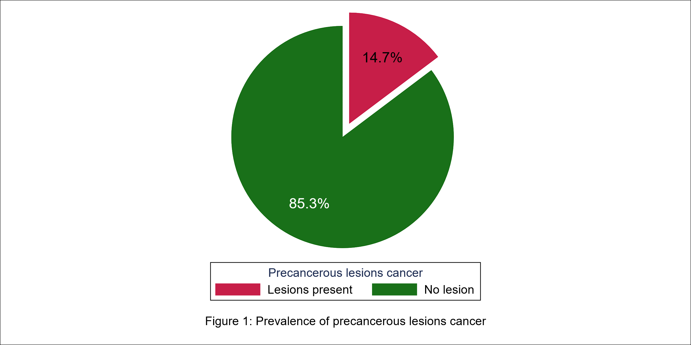

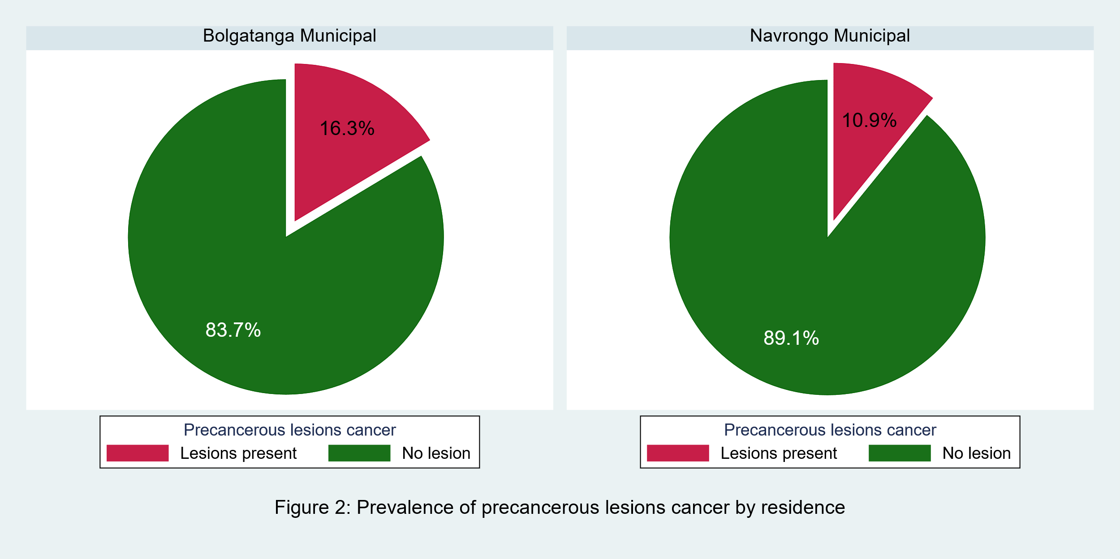

Associations between socio-demographic and lifestyle factors and the risk of developing precancerous lesions of the cervix

|  |  |  |  |  |
| --- | --- | --- | --- | --- |
| **Table 3: Associations between socio-demographic and lifestyle factors and the risk of developing precancerous lesions of the cervix** | | | | |
|  | **Precancerous lesions** | |  |  |
|  | **Lesions present** | **No lesion** | **Total** | **P-** |
| **Variables** | **(N=126)** | **(N=729)** | **(N=855)** | **value** |
|  | **n (%)** | **n (%)** |  |  |
| **Age** |  |  |  |  |
| 15-24 | 20 (15.9) | 121 (16.6) | 141 (16.5) | 0.877 |
| 25-34 | 34 (27.0) | 197 (27.1) | 231 (27.0) |  |
| 35-45 | 40 (31.7) | 201 (27.6) | 241 (28.2) |  |
| 46-55 | 16 (12.7) | 111 (15.2) | 127 (14.9) |  |
| >55 | 16 (12.7) | 98 (13.5) | 114 (13.3) |  |
| **Residence** |  |  |  |  |
| Bolgatanga Municipal | 99 (78.6) | 508 (69.7) | 607 (71.0) | 0.042* |
| Navrongo Municipal | 27 (21.4) | 221 (30.3) | 248 (29.0) |  |
| **Occupation** |  |  |  |  |
| Employed | 20 (15.9) | 193 (26.5) | 213 (25.0) | 0.091 |
| Self-employed | 68 (54.0) | 321 (44.2) | 389 (45.6) |  |
| Unemployed | 11 (8.7) | 52 (7.2) | 63 (7.4) |  |
| Student | 23 (18.3) | 128 (17.6) | 151 (17.7) |  |
| Retired | 4 (3.2) | 33 (4.5) | 37 (4.3) |  |
| **Monthly Income (GHC)** |  |  |  |  |
| < 1000 | 62 (49.6) | 314 (43.3) | 376 (44.2) | 0.189 |
| 1000 - 1999 | 16 (12.8) | 86 (11.8) | 102 (12.0) |  |
| 2000 - 2999 | 6 (4.8) | 86 (11.8) | 92 (10.8) |  |
| >=3000 | 11 (8.8) | 57 (7.9) | 68 (8.0) |  |
| No monthly income earnings | 30 (24.0) | 183 (25.2) | 213 (25.0) |  |
| **Religion** |  |  |  |  |
| Christianity | 114 (90.5) | 639 (87.7) | 753 (88.1) | 0.367 |
| Moslem | 12 (9.5) | 90 (12.3) | 102 (11.9) |  |
| **Marital status** |  |  |  |  |
| Married | 86 (68.3) | 482 (66.1) | 568 (66.4) | 0.530 |
| Single | 34 (27.0) | 184 (25.2) | 218 (25.5) |  |
| Divorced | 1 (0.8) | 11 (1.5) | 12 (1.4) |  |
| Widowed | 5 (4.0) | 52 (7.1) | 57 (6.7) |  |
| **Education level** |  |  |  |  |
| No formal education | 34 (27.0) | 126 (17.3) | 160 (18.7) | 0.026* |
| Primary | 14 (11.1) | 83 (11.4) | 97 (11.3) |  |
| Junior High School | 22 (17.5) | 97 (13.3) | 119 (13.9) |  |
| Senior High School | 19 (15.1) | 117 (16.0) | 136 (15.9) |  |
| Tertiary | 37 (29.4) | 306 (42.0) | 343 (40.1) |  |
| **Registered with National Health Insurance** |  |  |  |  |
| No | 3 (2.4) | 9 (1.2) | 12 (1.4) | 0.312 |
| Yes | 123 (97.6) | 720 (98.8) | 843 (98.6) |  |
| **Weight (Kg)** | 67.398 (14.41) | 67.759 (15.58) | 67.706 (15.41) | 0.808 |
| **Height (meters)** | 1.606 (0.09) | 1.602 (0.11) | 1.603 (0.11) | 0.749 |
| **BMI score** | 26.167 (5.39) | 29.821 (90.07) | 29.283 (83.19) | 0.649 |
| **BMI Category** |  |  |  |  |
| Underweight | 0 (0.0) | 34 (4.7) | 34 (4.0) | 0.060 |
| Healthy Weight | 61 (48.4) | 305 (41.8) | 366 (42.8) |  |
| Overweight | 39 (31.0) | 218 (29.9) | 257 (30.1) |  |
| Obese | 26 (20.6) | 172 (23.6) | 198 (23.2) |  |
| **Parity of participant** |  |  |  |  |
| Zero | 16 (13.4) | 145 (21.0) | 161 (19.9) | 0.033* |
| One | 18 (15.1) | 76 (11.0) | 94 (11.6) |  |
| Two | 18 (15.1) | 112 (16.2) | 130 (16.0) |  |
| Three | 20 (16.8) | 146 (21.1) | 166 (20.5) |  |
| Four | 20 (16.8) | 118 (17.1) | 138 (17.0) |  |
| Five | 15 (12.6) | 67 (9.7) | 82 (10.1) |  |
| Six and above | 12 (10.1) | 28 (4.0) | 40 (4.9) |  |
| **Age at first childbirth** | 20.890 (3.95) | 21.546 (5.50) | 21.440 (5.29) | 0.236 |
| **Age at first menstrual period** | 14.849 (1.82) | 14.791 (1.83) | 14.800 (1.83) | 0.741 |
| **Menopause** |  |  |  |  |
| No | 101 (80.2) | 545 (75.1) | 646 (75.8) | 0.218 |
| Yes | 25 (19.8) | 181 (24.9) | 206 (24.2) |  |
| **Have you ever taken alcohol before?** |  |  |  |  |
| No | 79 (62.7) | 468 (64.2) | 547 (64.0) | 0.746 |
| Yes | 47 (37.3) | 261 (35.8) | 308 (36.0) |  |
| **Have you ever smoked?** |  |  |  |  |
| No | 125 (99.2) | 727 (99.7) | 852 (99.6) | 0.363 |
| Yes | 1 (0.8) | 2 (0.3) | 3 (0.4) |  |
| **Ever use of a contraceptive method** |  |  |  |  |
| No | 44 (34.9) | 273 (37.4) | 317 (37.1) | 0.587 |
| Yes | 82 (65.1) | 456 (62.6) | 538 (62.9) |  |
| **Any history of breastfeeding** |  |  |  |  |
| No | 20 (16.0) | 177 (24.8) | 197 (23.5) | 0.033* |
| Yes | 105 (84.0) | 538 (75.2) | 643 (76.5) |  |
| **Age at first sexual intercourse** |  |  |  |  |
| < =15 | 15 (12.2) | 63 (8.9) | 78 (9.4) | 0.498 |
| 16-24 | 102 (82.9) | 604 (85.4) | 706 (85.1) |  |
| 25-34 | 6 (4.9) | 40 (5.7) | 46 (5.5) |  |
| **Number of current sexual partners** | 0.921 (0.35) | 0.881 (0.41) | 0.887 (0.40) | 0.299 |
| **Previously screened for cervical cancer** |  |  |  |  |
| No | 95 (75.4) | 515 (70.7) | 610 (71.4) | 0.286 |
| Yes | 31 (24.6) | 213 (29.3) | 244 (28.6) |  |

Socio-demographic and lifestyle factors associated with the risk of developing precancerous lesions of the cervix

NB. The base of interest: Lesion Present***

|  |  |  |  |  |  |  |
| --- | --- | --- | --- | --- | --- | --- |
| **Table 4: Socio-demographic and lifestyle factors associated with the risk of developing precancerous lesions of the cervix** | | | | | | |
| **Factors** | **Bivariate Model** | | | **Multivariate Model** | | |
|  | **cOR** | **95% CI** | **p-value** | **aOR** | **95% CI** | **p-value** |
| **Age** |  |  |  |  |  |  |
| 15-24 | 1.00 |  |  | 1.00 |  |  |
| 25-34 | 1.06 | 0.59 - 1.93 | 0.837 | 1.03 | 0.39 - 2.72 | 0.953 |
| 35-45 | 1.23 | 0.69 - 2.21 | 0.479 | 0.93 | 0.33 - 2.63 | 0.897 |
| 46-55 | 0.89 | 0.44 - 1.81 | 0.755 | 0.46 | 0.15 - 1.45 | 0.188 |
| >55 | 1.01 | 0.50 - 2.06 | 0.973 | 0.44 | 0.13 - 1.44 | 0.173 |
| **Residence** |  |  |  |  |  |  |
| Bolgatanga Municipal | 1.00 |  |  | 1.00 |  |  |
| Navrongo Municipal | 0.62 | 0.39 - 0.97 | 0.038* | 0.66 | 0.37 – 1.19 | 0.168 |
| **Occupation** |  |  |  | **-** | **-** | **-** |
| Employed | 1.00 |  |  |  |  |  |
| Self-employed | 2.04 | 1.20 – 3.47 | 0.008* |  |  |  |
| Unemployed | 2.04 | 0.92 - 4.53 | 0.079 |  |  |  |
| Student | 1.69 | 0.89 - 3.21 | 0.106 |  |  |  |
| Retired | 1.17 | 0.38 - 3.64 | 0.787 |  |  |  |
| **Monthly Income (GHC)** |  |  |  | **-** | **-** | **-** |
| < 1000 | 1.00 |  |  |  |  |  |
| 1000 - 1999 | 0.94 | 0.52 - 1.72 | 0.846 |  |  |  |
| 2000 - 2999 | 0.35 | 0.15 - 0.84 | 0.019* |  |  |  |
| >=3000 | 0.98 | 0.49 - 1.97 | 0.949 |  |  |  |
| No monthly income earnings | 0.82 | 0.51 - 1.31 | 0.401 |  |  |  |
| **Religion** |  |  |  | **-** | **-** | **-** |
| Christianity | 1.00 |  |  |  |  |  |
| Moslem | 0.72 | 0.38 - 1.35 | 0.302 |  |  |  |
| **Marital status** |  |  |  | **-** | **-** | **-** |
| Married | 1.00 |  |  |  |  |  |
| Single | 1.02 | 0.66 - 1.57 | 0.932 |  |  |  |
| Divorced | 0.51 | 0.06 - 4.00 | 0.521 |  |  |  |
| Widowed | 0.54 | 0.21 - 1.39 | 0.200 |  |  |  |
| **Education level** |  |  |  |  |  |  |
| No formal education | 1.00 |  |  | 1.00 |  |  |
| Primary | 0.63 | 0.32 - 1.24 | 0.176 | 0.50 | 0.24 - 1.06 | 0.069 |
| Junior High School | 0.84 | 0.46 - 1.53 | 0.569 | 0.67 | 0.33 - 1.34 | 0.255 |
| Senior High School | 0.60 | 0.33 - 1.11 | 0.106 | 0.48 | 0.22 - 1.04 | 0.064 |
| Tertiary | 0.44 | 0.27 - 0.74 | 0.002* | 0.37 | 0.18 - 0.77 | 0.008* |
| **Registered with NHIS** |  |  |  |  |  |  |
| No | 1.00 |  |  |  |  |  |
| Yes | 0.51 | 0.14 - 1.91 | 0.318 |  |  |  |
| **Weight (Kg)** | 1.00 | 0.99 - 1.01 | 0.790 | **-** | **-** | **-** |
| **Height (meters)** | 1.34 | 0.21 - 8.48 | 0.757 | **-** | **-** | **-** |
| **BMI score** | 0.99 | 0.96 - 1.02 | 0.593 | **-** | **-** | **-** |
| **BMI Category** |  |  |  | **-** | **-** | **-** |
| Underweight | 1.00 |  |  |  |  |  |
| Healthy Weight | 1.33 | 0.81 - 2.19 | 0.254 |  |  |  |
| Overweight | 1.20 | 0.70 - 2.04 | 0.509 |  |  |  |
| Obese | 1.00 |  |  |  |  |  |
| **Parity of participant** |  |  |  |  |  |  |
| Zero | 1.00 |  |  | 1.00 |  |  |
| One | 2.12 | 1.02 - 4.39 | 0.043* | 0.17 | 0.03 - 0.95 | 0.043* |
| Two | 1.46 | 0.71 - 2.98 | 0.304 | 0.12 | 0.02 - 0.63 | 0.013* |
| Three | 1.24 | 0.62 - 2.49 | 0.543 | 0.10 | 0.02 - 0.52 | 0.007* |
| Four | 1.54 | 0.76 - 3.10 | 0.230 | 0.12 | 0.02 - 0.64 | 0.014* |
| Five | 2.03 | 0.95 - 4.35 | 0.069 | 0.15 | 0.02 - 0.85 | 0.032* |
| Six and above | 3.88 | 1.66 - 9.09 | 0.002* | 0.33 | 0.05 - 2.03 | 0.232 |
| **Age at first childbirth** | 0.98 | 0.94 - 1.01 | 0.235 | 0.98 | 0.93 - 1.04 | 0.589 |
| **Age at first menstrual period** | 1.02 | 0.92 - 1.13 | 0.768 | **-** | **-** | **-** |
| **Menopause** |  |  |  | **-** | **-** | **-** |
| No | 1.00 |  |  |  |  |  |
| Yes | 0.75 | 0.47 - 1.20 | 0.228 |  |  |  |
| **Have you ever taken alcohol before?** |  |  |  | **-** | **-** | **-** |
| No | 1.00 |  |  |  |  |  |
| Yes | 1.07 | 0.73 - 1.59 | 0.722 |  |  |  |
| **Have you ever smoked?** |  |  |  | **-** | **-** | **-** |
| No | 1.00 |  |  |  |  |  |
| Yes | 2.92 | 0.26 -32.44 | 0.383 |  |  |  |
| **Ever use of a contraceptive method** |  |  |  | **-** | **-** | **-** |
| No | 1.00 |  |  |  |  |  |
| Yes | 1.12 | 0.75 - 1.66 | 0.583 |  |  |  |
| **Any history of breastfeeding** |  |  |  |  |  |  |
| No | 1.00 |  |  | 1.00 |  |  |
| Yes | 1.72 | 1.04 - 2.86 | 0.035* | 8.28 | 1.29 -53.12 | 0.026 |
| **Age at first sexual intercourse** |  |  |  | **-** | **-** | **-** |
| < =15 | 1.00 |  |  |  |  |  |
| 16-24 | 0.71 | 0.39 - 1.29 | 0.258 |  |  |  |
| 25-34 | 0.63 | 0.23 - 1.76 | 0.378 |  |  |  |
| **Number of current sexual partners** | 1.25 | 0.77 - 2.02 | 0.367 | **-** | **-** | **-** |
| **Previously screened for cervical cancer** |  |  |  | **-** | **-** | **-** |
| No | 1.00 |  |  |  |  |  |
| Yes | 0.79 | 0.51 - 1.23 | 0.298 |  |  |  |

**\*** Statistically significant at p<0.05; ***cOR:*** Crude Odds Ratio; ***aOR***: Adjusted Odds Ratio; ***CI***: Confidence Interval

Barriers to the utilization of cervical cancer screening services

